
Project Report: AI-Driven Air Quality Index (AQI) Predictor & Expert System

Course: Fundamentals in AI and ML (CSA2001)
Assignment: BYOP (Bring Your Own Project) Capstone
Student Name: Ananya Tiwari
Registration Number: 25BAI11158
GitHub Repository Link: https://github.com/Tetbet/AQI_Predictor_BYOP

1. The Problem and Why It Matters
Air pollution is one of the most severe public health crises in India. Every day, millions of citizens step outside without realizing the immediate danger of the air they are breathing. While historical data exists, making real-time predictions based on fluctuating local pollutant levels (like PM2.5, NO2, and Ozone) is difficult for the average person to interpret.
This problem matters because prolonged exposure to poor air quality without precautions (like wearing an N95 mask or avoiding outdoor exercise) leads to severe respiratory illnesses. I chose this problem because it is highly relevant to my environment, and it presents a perfect opportunity to apply both Data-Driven Machine Learning and Rule-Based AI to create a system that not only predicts environmental metrics but also advises human action.
2. Approach to Solving the Problem
To solve this, I designed a Hybrid AI System that maps directly to the course syllabus. My approach was divided into four main phases:
- Exploratory Data Analysis (EDA) & Cleaning: I utilized the "Air Quality Data in India (2015-2020)" dataset. Because sensor data often cuts out due to power failures, the raw data had thousands of missing values. I used Pandas to clean this data and Seaborn/Matplotlib to visualize pollutant correlations.
- Regression Analysis (Predicting the Number): I trained a Random Forest Regressor to take six raw chemical pollutant levels and predict the exact numerical AQI.
- Classification (Predicting the Category): I trained a Random Forest Classifier to categorize the air quality into standard health buckets (e.g., "Moderate", "Severe").
- Knowledge Representation (Prolog Expert System): To fulfill CO6 of the course, I built a symbolic AI in Prolog. It uses logical rules to take the predicted AQI category and deduce the necessary real-world health precautions.
3. Key Decisions Made
Throughout the development process, I had to make several engineering decisions to ensure the project was purposeful and well-executed:
- Handling Missing Data via Forward-Fill (ffill): Initially, I considered dropping rows with missing (NaN) values. However, I realized that since this is time-series data (recorded day by day), dropping rows would destroy the timeline. Instead, I decided to use forward-filling (assuming today's missing sensor reading is similar to yesterday's). This saved thousands of rows of valuable training data.
- Choosing Random Forest over Linear Regression: Environmental data is highly non-linear (e.g., a tiny increase in PM2.5 might cause a massive spike in AQI). I decided to use a Random Forest algorithm because it handles non-linear relationships and complex feature interactions much better than simple linear models.
- Cloud-Hosted Dataset for Reproducibility: To ensure the evaluator could easily test my project, I decided to host the city_day.csv dataset directly on my public GitHub. This decision allows my Google Colab notebooks to pull the data dynamically, requiring zero local setup for the user.
- Adding a User Interface (Gradio): Instead of just printing numbers in a console, I decided to build a Gradio Web UI inside my notebook so users can interact with the ML models in real-time.
4. Challenges Faced
- Data Quality: The biggest challenge was the raw Kaggle dataset. Some cities had entirely blank columns for certain pollutants for months at a time. I had to write custom grouping logic (df.groupby('City').ffill()) to ensure I didn't accidentally fill Delhi's missing data with Mumbai's sensor readings.
- Bridging Python and Prolog: Machine Learning (Python) outputs probabilities and numbers, but Prolog requires strict symbolic logic (True/False facts and rules). It was challenging to conceptualize how they fit together. I overcame this by clearly separating their roles: Python handles the statistical prediction, while Prolog handles the deterministic health advisory rules.

5. Results and Visualizations
A. Exploratory Data Analysis
Figure 1: Distribution of Air Quality Categories across Indian cities, showing the imbalance between 'Good' days and 'Severe' days.
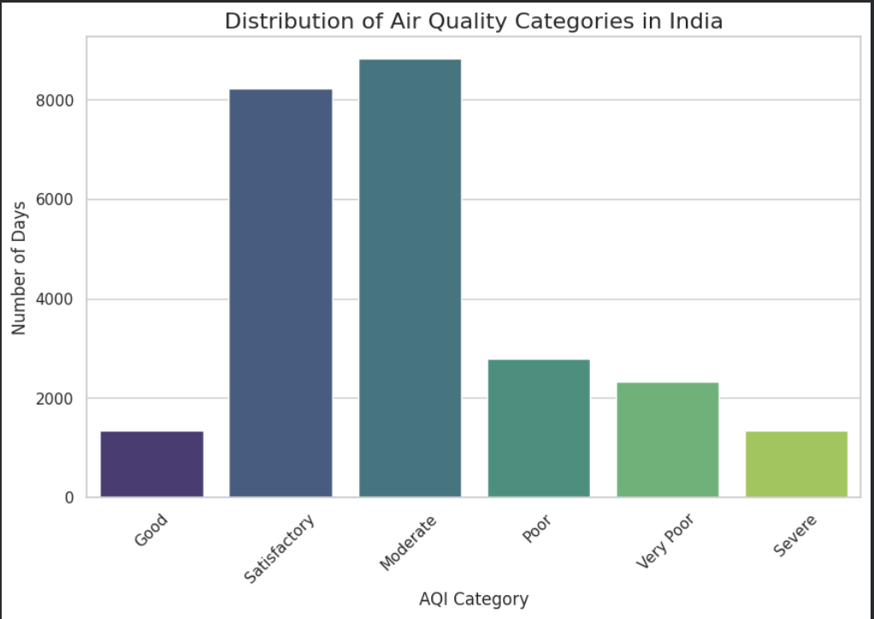

Figure 2: Correlation heatmap revealing that PM2.5 and PM10 have the strongest statistical correlation with the final AQI number.
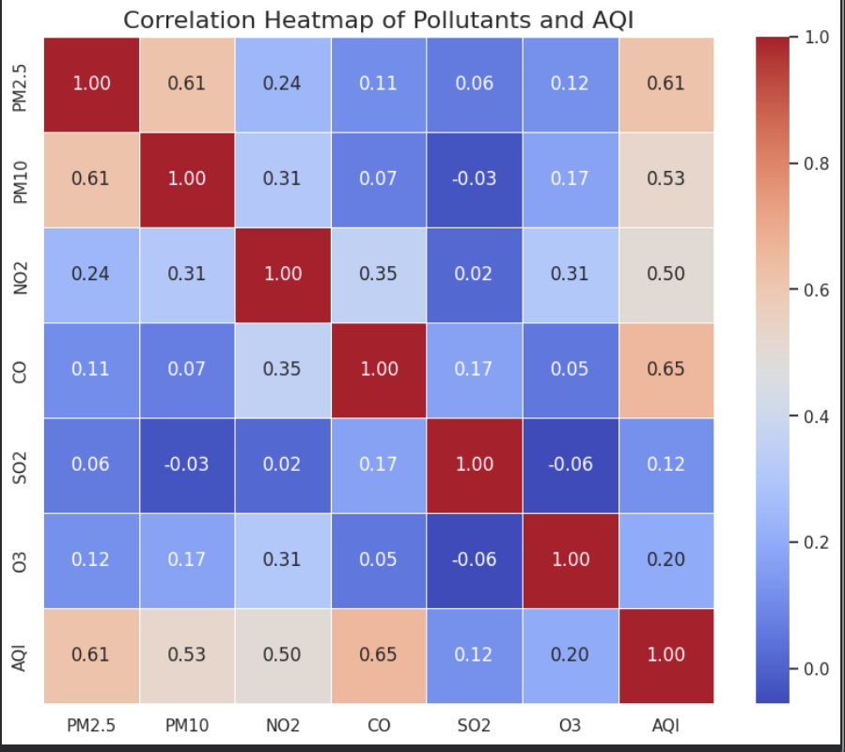

B. Real-Time User Interface
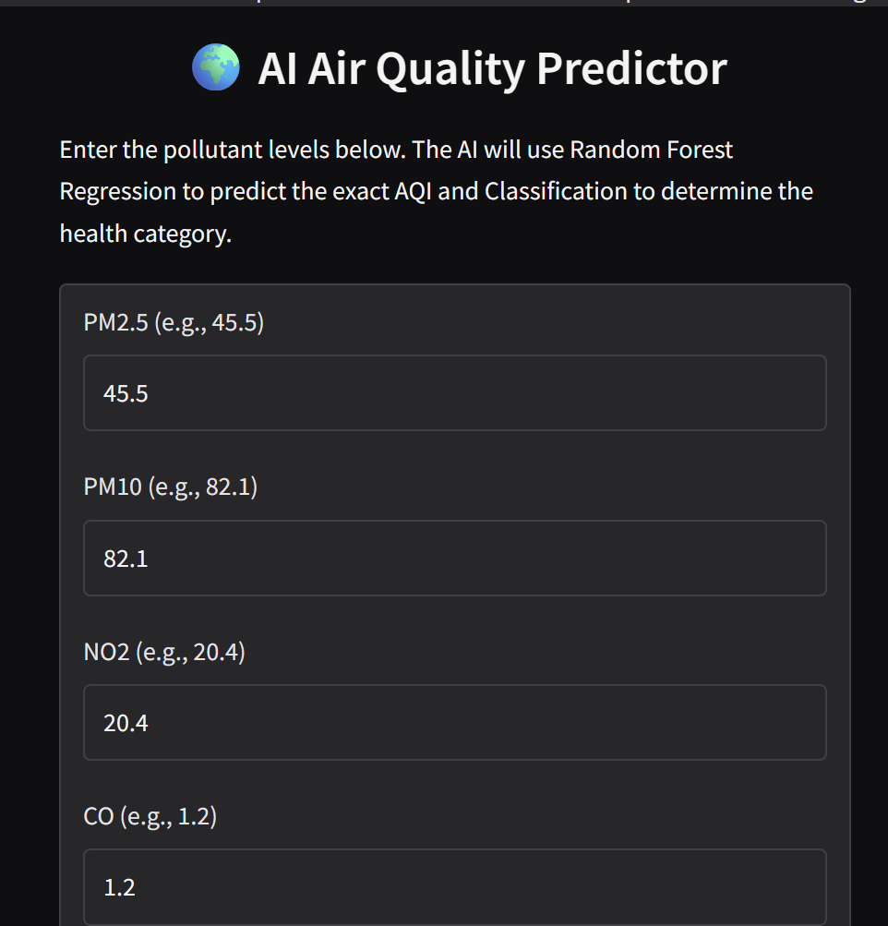
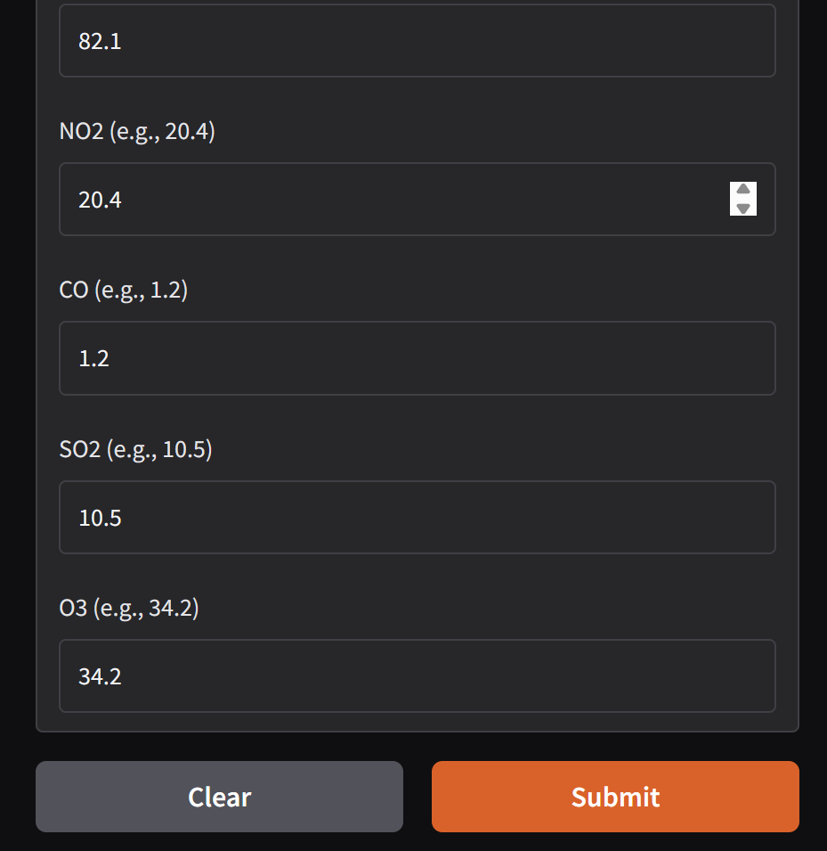
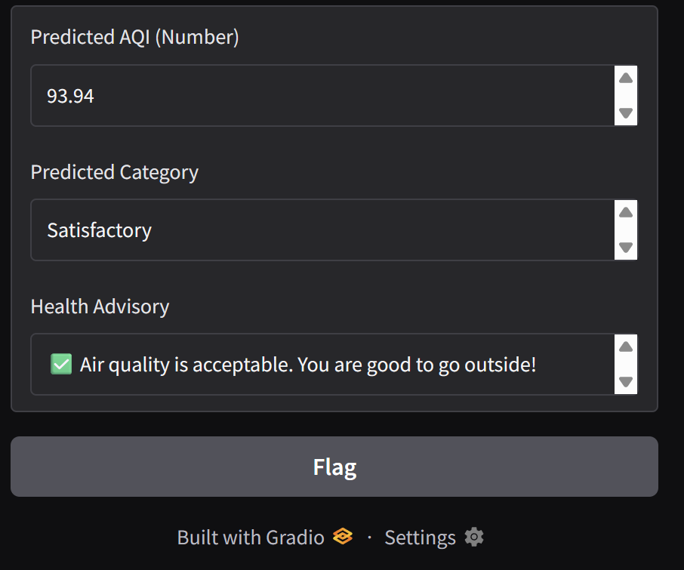
Figure 3: The interactive web interface where users can input real-time pollutant metrics to receive an AI-generated health advisory.
6. What I Learned
Completing this Bring Your Own Project (BYOP) solidified my understanding of the theoretical concepts taught in CSA2001. Specifically:
- I learned the practical difference between Classification (discrete categories) and Regression (continuous numbers) by implementing both on the exact same dataset.
- I gained hands-on experience with hyper-parameters and mitigating overfitting during the model training phase.
- I learned how to write Propositional and First-Order logic rules in Prolog to build an Expert System.
- Most importantly, I learned that building an AI solution is 80% about understanding and cleaning the data, and 20% about writing the actual machine learning algorithms.

